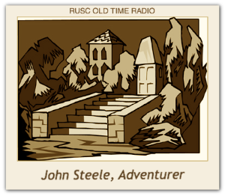

John Steele, Adventurer
First broadcast in 1949, John Steele, Adventurer was a thriller/drama that wasn’t considered a major force in the world of radio although it is considered to have offered great entertainment. Jungles and deserts made up the eerie background sounds of the series that featured Don Douglas as John Steele.
John Steele was the type of roving adventurer and thrill seeker who held various jobs in exotic locations. Among his career paths were country sheriff, special agent in Turkey and a ship’s captain.
The stories were narrated by a friend of Steele’s, with Steele making cameo appearances throughout. Ted Mallie, of The Shadow and I Love a Mystery announcing fame also landed the job of the announcer for John Steele, Adventurer, which featured Elliot Drake as the director.
John Larkin, Jack Edwards, Bryna Raeburn and other radio personalities were also featured in the series as supporting actors. Music for the series added tones of mystery and adventure and was produced by Sylvan Levin and later, Doc Whipple.
Fans of the John Steele, Adventurer enjoyed the hard and fast-paced action and the stories seemed to be lifted off the pages from popular action magazines of the time such as All-Story and Argosy. To overcome the challenges of a radio show featuring a person who couldn’t speak, the producers represented the boy’s thoughts (rather than speaking voice) by using an echo chamber. It was considered a very moving and adventurous story of the series.
At the end of each story in the series, John Steele’s voice would comment, “A life of adventure is yours for the asking, but don’t look for it; it may find you! Happy hunting!”
John Steele, Adventurer made lots of fans during its time on the air and even though its overall rating wasn’t as high as other radio shows it was very entertaining.
This series synopsis is courtesy of R U Sitting Comfortably at http://www.rusc.com
For the Old Time Radio Researchers, I’m __________________, your announcer. Now on with the show!

